Dear Raghavendran,

It is a pleasure to invite you to our company Medevplus, named as Tishya’s Medical Device Development Solutions Pvt Ltd, Bangalore to work on a project titled **“Dissolved Oxygen Sensor”**.

**Project application:**

1. To read the amount of dissolved oxygen in the water. Main application is to be used in pisciculture where the oxygen levels are to be maintained for the survival of the aqua life system and in further planning to broader the application in agriculture, plantations, etc.

**Project details:**

1. There is Optics design involved which is sourced by 3 lasers and the light data is read by 3 detectors respectively aligned in their positions of incident.
2. 3 lasers should be driven with constant power (mentioned in the datasheet)
3. 3 detectors read analog data (mentioned in the datasheet) should be read using ADC and transmitted to MCU
4. Over some algorithmic firmware, the data is transmitted to another system over MAX485

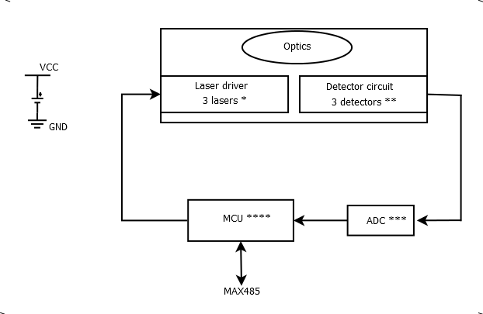

**Note:**

3 lasers * - G650 pigtailed laser

3 detectors ** - S2386-18L or S2387-66R according to the lab results it will be changed

ADC *** - ADS111X series with 3 channel analog input and 16bit digital output through I2C protocol

MCU **** - STM32Fxx series

12V battery will be used as Power supply

The datasheets of the lasers and detectors are attached over the mail along with this document.

The step file of the enclosure will be attached over the mail and the PCB should be designed to fit into that. The placement of the lasers and detectors are mentioned with their dimensions.

**Deliverables:**

All the datasheets, BOM, schematics, layout design and gerber files needed for further changes and production.

Need your help in BIS compliance documentation and service till the product is certified.

Yours Sincerely,

Sachin S Munji

R&D Systems Engineer

Approved by: Accepted by:

Ravi Kiran Manapuram, PhD Raghavendran

Principal Investigator and Director (PCB Hardware design Engineer)